Complex Queries

1. WRITE A SQL STATEMENT TO DISPLAY THE LOWEST PAID EMPLOYEE'S (NAME , SALARY , DEPARTMENT NAME)

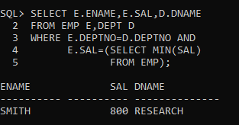

1. LIST MINIMUM SALARY FOR EACH DEPARTMENT

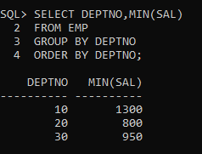

1. WRITE A QUERY BASED ON FOLLOWING RESULT.

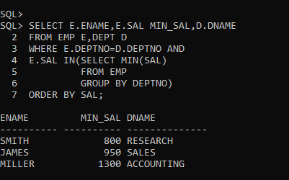

1. LIST ALL THE EMPLOYEES WHO ARE WORKING IN FORD’S DEPARTMENT.

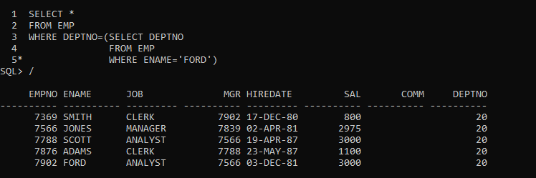

1. LIST ALL EMPLOYEE WHO ARE WORKING IN WARD'S DEPARTMENT AND

EARNING MORE THEN MARTIN

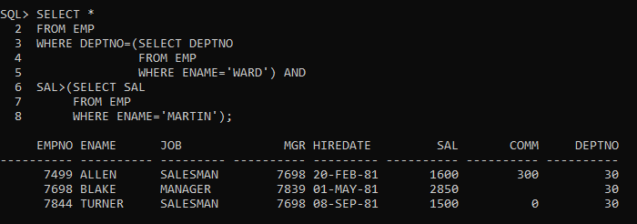

1. DISPLAY EMPLOYEE NUMBER, NAME,DEPT NUMBER, DEPT NAME, AND LOCATION

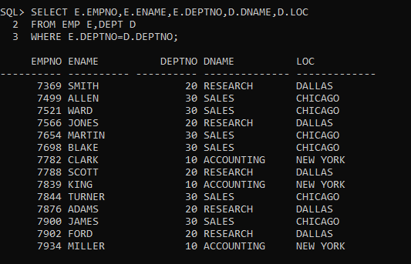

1. DISPLAY THE FOLLOWING RESULT

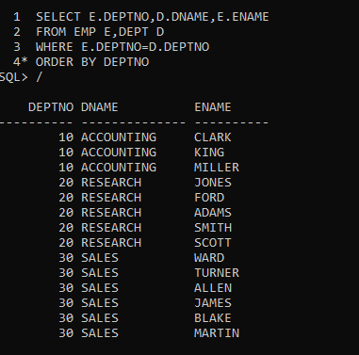

1. LIST ALL THE EMPLOYEE WHO ARE WORKING IN NEW YORK

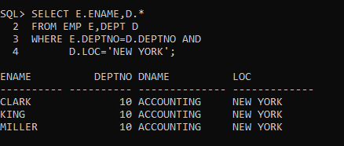

1. WRITE A SQL STATEMENT TO DISPLAY THE LOWEST PAID EMPLOYEE'S (NAME , SALARY , DEPARTMENT NAME) IN THE RESPECTIVE DEPARTMENT.

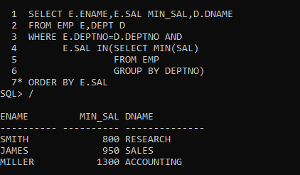

1. WRITE A SQL STATEMENT TO DISPLAY THE HIGHEST PAID EMPLOYEE'S (NAME, JOB, MANAGER NAME, SALARY AND DEPARTMENT NAME AND DEPARTMENT NO.) IN THE RESPECTIVE DEPARTMENT.

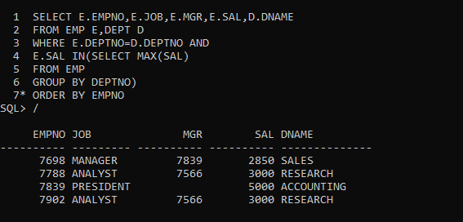

1. WRITE A SQL STATEMENT TO DISPLAY THE EMPLOYEE NAME (BOSS) AND NUMBER OF EMPLOYEE (SUBORDINATES) DIRECTLY REPORTING TO HIM?

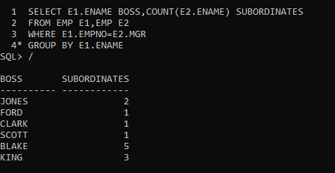

1. DISPLAY THE NAMES, DESIGNATION AND SALARIES OF ALL EMPLOYEES WHO HAVE MANAGER ALONG WITH MANAGER'S NAME, DESIGNATION AND MANAGER'S SALARY.

(SELF-JOIN)

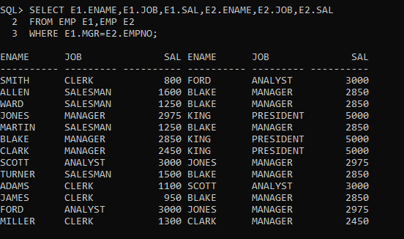

1. Create the following tables:

ORDER: {Id, OrderDate, OrderNumber}

ORDER_ITEM: {Id, OrderId, ProductId, UnitPrice, Quantity}

PRODUCT: {Id, ProductName}

Write a query to display the following output sorted by order no:

1. Find the 2nd minimum salary of the employee.

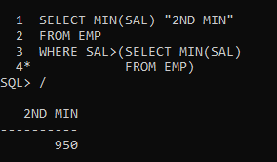

1. Find the max 3 salaries from employee table.

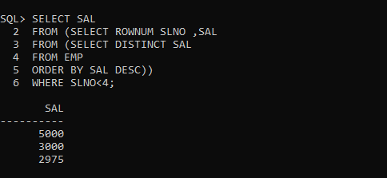

1. Display common records from emp_1 & emp_2 tables. (Use INTERSECT)

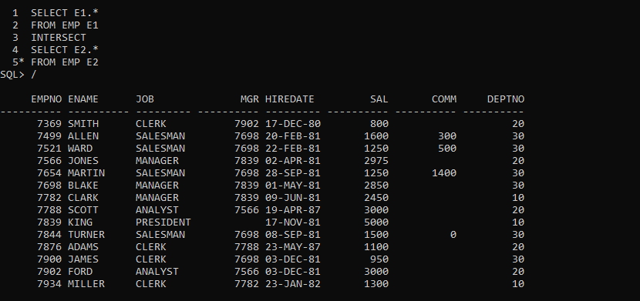

1. Display department no wise total salary where more than 2 employees exist in a department.

